Mad Jack Fuller’s follies and other works

The Obelisk
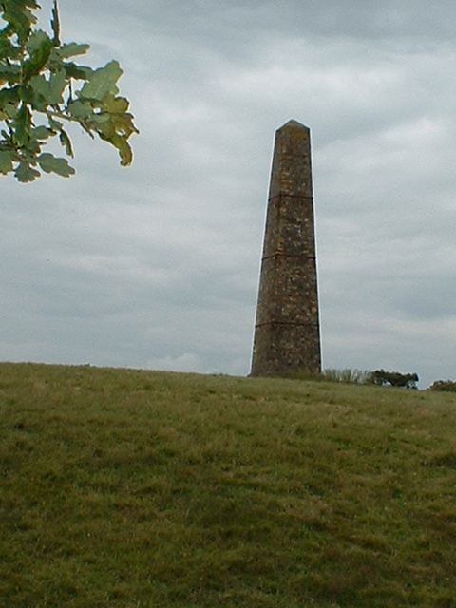
Also known as the Brightling Needle, this obelisk stands atop a hill, variously known as Brightling Down and Brightling Beacon, that is 646 feet (187 m) above sea level, making it the second highest point in East Sussex.

The obelisk itself is 65 feet (20 m) high. The reason for its existence is open to conjecture. Some sources claim that it was erected to commemorate Nelson's victory at Trafalgar in 1805. Still others purport that it stands in celebration of Wellington's victory over Napoleon in 1815. It seems odd, however, that there is no inscription on the monument, another mystery left by Jack Fuller.

In 1985, extensive renovations were carried out to strengthen and stabilize the obelisk. Two local men who were involved with earlier repairs scratched these words into the structure: R Croft, 1899; and Charles Croft, July 29, 1889, aged 16 years

The Observatory
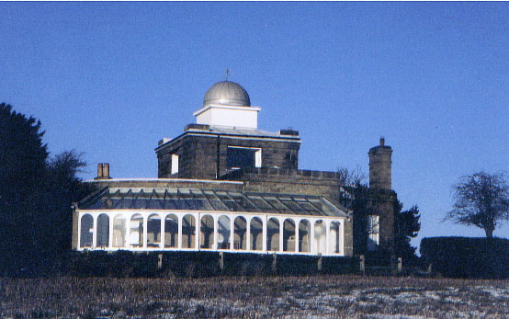
Designed by Sir Robert Smirke for Jack Fuller in 1810, the Brightling Observatory was completed in 1818. It is located on the Brightling-Burwash road, at latitude 50 57 44 and in longitude 0 22 42E, and is now a private residence.
The Observatory was equipped with expensive equipment including a Camera Obscura. During the 19th century, room Camera Obscuras became very popular across Europe. Originating from the Latin meaning " dark room " the Camera Obscura is considered the forerunner of the modern portable camera. Through a tiny hole in one wall, replaced in later models by a lens, an image was projected onto the opposite wall. Artists used different types of Camera Obscura to trace accurate images from nature and incorporate these images into their drawings and paintings. With this in mind, one wonders if frequent visitor to Rose Hill, J M W Turner may have made use of the Camera Obscura while there.

The Rotunda Temple
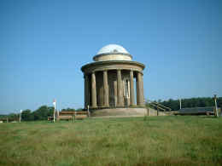
Standing stately atop a small hill in Brightling Park is the Greek, or perhaps more properly, Rotunda Temple. It was suggested by Sir Humphry Repton in his plans for the garden and is thought to have been designed by Sir Robert Smirke. The Temple is approximately 25 feet (7.62 m) tall and was built around 1810. This circular building has a hollow base that was perhaps used to store food and wine.
On 20 September, 1808 Covent Garden Theatre burnt down. It was redesigned by Sir Robert Smirke opening less than a year later on 18 September, 1809. It demonstrates the neo-classical style so much in favour at the time.

The Rotunda Temple has spawned several stories about Fuller and his cohorts. It has been said that he entertained lady friends there...perhaps even held orgies. Others speculate that he held card parties in the temple and gambled with his cronies for very high stakes. Unfortunately, we may never know exactly what went on.

The Pyramid
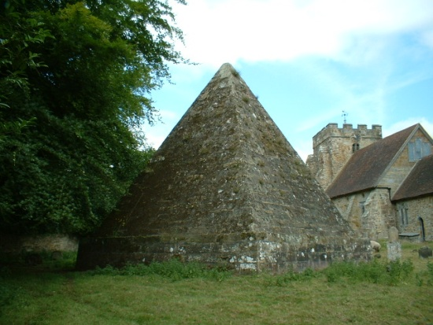
Jack Fuller's pyramid is a 25 foot (7.62 m) high mausoleum built in 1811, twenty-three years before his death. It stands in the churchyard of St. Thomas à Becket, Brightling.
The ninth verse of Grey's Elegy is inscribed on one wall:
'The boast of heraldry, the pomp of pow'r
And all that beauty, all that wealth e'er gave
Await alike th' inevitable hour
The paths of glory lead but to the grave'

Local legend had it that Fuller was entombed in the pyramid in full dress and top hat seated at a table set with a roast chicken and a bottle of wine. This was discovered to be untrue during renovations in 1982. Fuller is indeed buried in the conventional manner beneath the pyramid

The Summerhouse
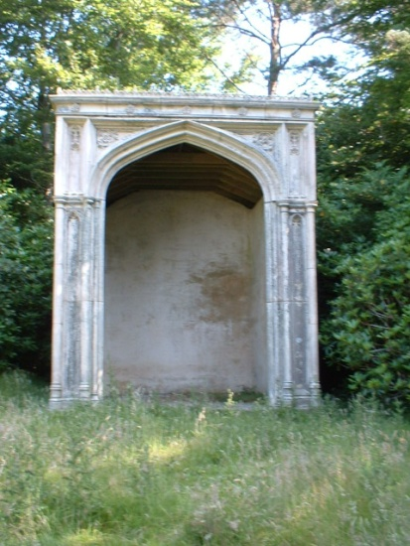
Jack Fuller's first venture into folly building was the Coade stone summerhouse erected in 1803. It is located in the woods on the west side of Brightling Park.
The magnificent molded Coade stone facade is backed by a semicircular structure made of brickwork. There are two inscriptions on the inside of the arch that both read: COADE SEALY LONDON.
Coade stone, an exceptionally hard and durable artificial material that closely resembles stone and was molded and then fired in a kiln.
Founded by Eleanor Coade in 1769, the Coade Manufactory produced monuments and other objects. John Sealy was her nephew and business partner. Fine examples that have weathered well include the Westminster Bridge Coade Stone Lion and Captain Bligh's Tomb both in London.

The Sugarloaf
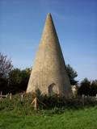
Also known as Fuller's point, this folly stands 35 feet (10.7 m ) tall in a meadow just off the Battle-Heathfield road.
Legend has it that Fuller made a bet that he could see the spire of St Giles, Dallington from his house. Upon realizing that this was not true he had workmen erect this folly in order to win the bet.
It is thought to have been built in the early 1820s and gets its name from the conical loaf form that sugar was sold in at that time.

The Tower
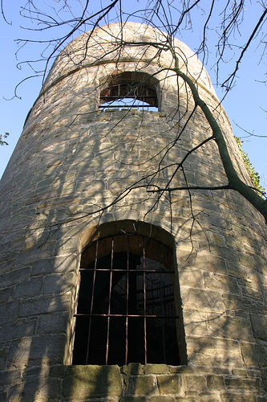
Fuller's Tower is the stuff from which legends are made!
It is approximately 35 feet (10.6 m) high and 12 feet (3.7 m) in diameter and is thought to have been built in the late 1820s. It is located off the Brightling-Darwell Hole road, about a quarter mile south east of Brightling Park. The tower can be reached by a small footpath.

John Frederick wrote,
"Within a clump of firs on an eminence not far from the church there stood, up till fairly recently, a very solidly built round tower. From the top of this, which before some mischievous boys set fire to the stairs and flooring within, was easily accessible, a wide panorama of undulating country could be seen. I was told that Fuller used to come here to watch from afar the construction of the railway through Robertsbridge, four miles away. Another fable connects the structure with the threatened Napoleonic invasion; the one version seems of too early a date and the other too late.
(A Village's Queer Building, SCM Vol II No. 10, Oct 1928, pp. 442-443)

It is also said that Jack Fuller had this tower built so that he could keep an eye on the workmen's progress during the restoration of Bodiam Castle. There has been some conjecture that it was used as a signalling tower.

None of these explanations for the tower's existence are persuasive. The South Eastern & Chatham Railway linked Robertsbridge to Tunbridge Wells in 1851 and Battle in 1852. The Kent & East Sussex Light Railway did not reach Robertsbridge until 1900. So the tower was not built for "trainspotting". Napoleon met his Waterloo on 18th June 1815 so there was no threat of invasion at the time the tower was erected. Fuller purchased Bodiam castle in 1829 and it seems that the Tower was built before then.

The Estate Wall
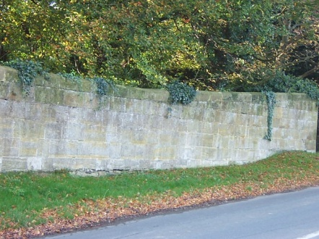
After 1815 and the defeat of Napoleon, there was a great deal of unemployment in the south of England. To alleviate the burdens of the poor on Brightling parish, Jack Fuller created building projects the most extensive of which was the wall around his entire Rose Hill Estate. The stone wall, built between 1815 and 1817, is approximately four feet (1.2 m) high and four miles (6.4 km) long. It has withstood the ravages of time quite well.

Brightling Churchyard wall (and gateway)
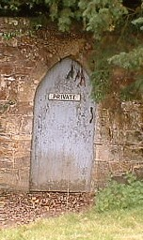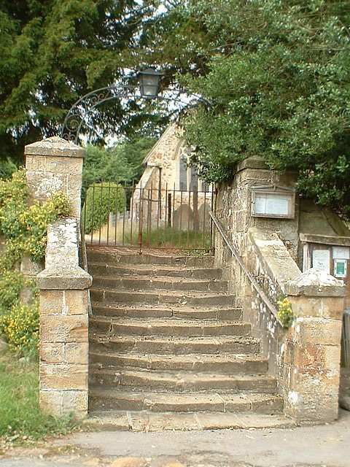
In exchange for permission to build his pyramid mausoleum in Brightling churchyard, Fuller agreed to build a wall around the churchyard. Fuller fulfilled his part of the bargain and added an iron gateway at the top of the stairs to the churchyard which is flanked by stone pillars. An iron lantern is suspended at the middle of the arch. Inserted into the churchyard wall is what has become known as the "Squire's Door" presumably so that Fuller had easy access to the church from his house at Rose Hill.

The Stone Pillar
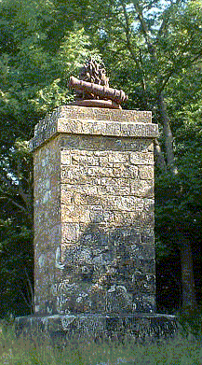
Fuller had two stone pillars constructed on his estate. One was erected some 100 yards (91.4 meters) south of the observatory in a copse of trees. It is reported to have disappeared. The remaining pillar is located in Brightling Park about 100 yards (91.4 meters) south of the house. It is approximately twelve feet (3.6 m) high and is crowned with a cast iron sculpture that depicts a cannon, flames and an anchor. This no doubt pays tribute to the Fuller family's history as gunfounders.

